**CHAPTER-I**

**INTRODUCTION**

**INTRODUCTION**

Traffic is on the enlargement because the interest for vehicles is obtaining higher step by step. During this manner, transportation wants improvement. Since the strain increasing with the progression within the vehicle business, there'll be a bigger probability of auto accidents. It'll be a considerable result if people cannot get assistance at the correct time. The Poor emergency incidents could be a serious reason for the death rate associated with vehicle accidents in our country. Our project can facilitate taking care of this issue by guaranteeing fast emergency service once an accident. The mechanism is put in on the vehicle. Once the vehicle is running unremarkably i.e., no accident has nonetheless occurred, then no data is shipped to emergency groups.

However, within the prevalance of an accident, the vehicle changes its orientation and produces alternate vary of waves therefore, increasing the frequency. GSM is an open, advanced cellular innovation used for causation versatile voice and knowledge services. The GSM framework is the most generally used cellular innovation being employed in the world nowadays. It’s been a particularly effective wireless innovation for a spread of reasons together with the capability to vagabond worldwide with the sureness of getting the choice to figure on GSM networks. It’s in addition deeply economic and more cost effective. The framework utilizes a GPS module to pass the message onto your portable with the placement of the accident. The placement of the accident spot is shipped within the kind of Google Map link, derived from the latitude and longitudes from the GPS module. The message in addition contains the speed of auto in knots.

**CHAPTER-II**

**PROBLEM IDENTIFICATION**

**PROBLEM IDENTIFICATION**

An accident happens at night or in areas where no individuals are heard in that particular setting and victims are not saved at the right time. Many of them are losing their lives because of this. This device solves the above problem by submitting data directly after an accident to the emergency team.

**CHAPTER-III**

**OBJECTIVE**

**OBJECTIVE**

• To locate vehicle 's location and transfer information to monitoring station.

• To integrate Global Positioning System (GPS) based tracking system for positioning information.

• To choose Global System for Mobile Communication (GSM) for information transmission and acquisition of vehicle 's location information (latitude, longitude).

* To develop software to display all transmitted information to the end user.

**CHAPTER-IV**

**LITERATURE SURVEY**

**LITERATURE SURVEY**

**PAPER-1**

**TITLE : Accident Alert and Vehicle Tracking System using GPS and GSM**

AUTHORS : J. Mounika, N. Charanjit, B. Saitharun & B. Vashista

**LITERATURE SURVEY** : Nowadays, road accidents area unit terribly high. On time medical care will facilitate in saving lives. Integrated engineering could be a latest trend to unravel issues. To be able to style a product exploitation an integrated technology are going to be useful to any engineering issues and an enormous contribution to the community.

An important indicator of survival rates when an accident is that the time between the accident and once emergency medical personnel area unit sent to the accident location. By eliminating the time between once an accident happens and once the primary responders area unit sent to the scene decree ses mortality rate and might save lives. One approach to eliminating the delay between accident prevalence and 1st communicator dispatch is to use in vehicle automatic accident detection and notification systems. Additionally trailing a vehicle just in case of any stealing has become a tricky job. This method aims to alert the close to and expensive ones of the person within the vehicle concerning the accident to supply immediate medical care. During this System once a vehicle meets with an accident directly Impact detector, electricity detector electrical device, small electro system can detects the signal and sends it to Arduino (Atmega328P). Directly microcontroller sends the signal to GPS module to convey the precise price of the geographical coordinates that contains the worth of meridian, latitude and altitude. At the moment the microcontroller sends the alert message through the GSM module to the close to and dear ones. additionally just in case of any stealing our project facilitates the owner to induce his vehicle’s position in terms of Latitude and meridian and a link directing to the google maps once the owner sends a SMS to the SIM employed in the system.

**PAPER-2**

**TITLE : VEHICLE ACCIDENT DETECTION SYSTEM USING GSM AND GPS**

AUTHORS : GOWSHIKA.B , MADHU MITHA.G , JAYASHREE.S

**LITERATURE SURVEY** : At present criteria, we have a tendency to cannot discover wherever the accident has occurred and thus no info associated with it, resulting in the death of a private.

The analysis work goes on for following the position of the vehicle even in dark clumsy areas wherever there's no network for receiving the signals.

During this project GPS is employed for following the position of the vehicle, GSM is employed for causation the message and therefore the ARM controller is employed for saving the mobile range within the EEPROM associated sends the message to that once an accident has been detected.

From the past event and therefore the existing approach the below downside square measure been noted:

1. Manual system is adopted.

2. Following of accident could be a crucial method within the system.

3. Needed medical attention cannot be given to the required person.

4. Life loss and property loss weren't stopped in massive scale. Considering all the drawbacks under consideration we've developed a projected system that covers all the on top of mentioned drawbacks.

5. The machine-driven system is employed once the accident happens.

6. This technique GSM can send the message to the additional Human life is saved victimisation this machine-driven system. Considering all the drawbacks under consideration we've developed a projected system that covers all the on top of mentioned drawbacks.

**PAPER-3**

**TITLE : GSM based Vehicle Accident Alert System**

AUTHORS : G. Boopathi Raja, Keerthika A, Keerthika S G, Nandhini A, Pranitha K J

**LITERATURE SURVEY** : One of the fundamental reasons for road accid ents is speed.

Road accidents are rising suddenly these days and ar one amongst the key causes of human deaths. Human life is additional vital than anything else, and timely help is additional vital than lending a help. If emergency service may get accident reports and reach it in time, additional lives may are saved.

In saving human lives, the time between the accident and once the car reaches the positioning of the accident plays Associate in Nursing important role. If we have a tendency to cut back the time between once Associate in Nursing accident happens and once a medical car is sent to the area, we will save human lives by reducing mortality rates. GPS has become Associate in Nursing integral a part of a vehicle system today. The accelerometer senses a sudden shift within the vehicle's axles. It will be tested by Arduino.

**PROBLEM IDENTIFICATION**

An accident happens at nighttime or in areas wherever no people are detected therein specific setting and victims don't seem to be saved at the correct time. Many of them are losing their lives owing to this.

This device solves the on top of drawback by submitting knowledge directly once AN accident to the emergency team.

**PROPOSED SYSTEM**

To instantly rescue accident victims by causation a message to the rescue team with a MEMS measuring device, GSM and GPS location.

**PAPER-4**

**TITLE : Vehicle Tracking System using GPS-GSM , Accident Detection and Theft Security**

AUTHOR : Dr. Pradnya Mathurkar , Akansha B. Somkuwar , Ashwini R. Thakre , Pranali M. Wasnik

**LITERATURE SURVEY** : A vehicle pursuit system is incredibly helpful for pursuit the movement of a vehicle from any location at any time. AN economical vehicle pursuit system is meant and enforced for pursuit the movement of any equipped vehicle from any location at any time. The planned system created smart use of popular technology that mixes a smartphone with an Arduino UNO. This simple to create and inexpensive compared to others. The designed in vehicle device works exploitation world Positioning System (GPS) and world System for Mobile Communication(GSM) technology that's one amongst the foremost common ways for vehicle pursuit. The device is embedded within a vehicle those positions is to be determined and tracked in real time. A vehicle pursuit system is an device put in a very vehicle to alter the owner or a 3rd party to trace the vehicle's location. This paper planned to style a vehicle tracking system that works exploitation GPS and GSM technology, which might be the most affordable supply of vehicle pursuit and it might work as anti-theft system. It's AN embedded system that is employed for tracking and positioning of any vehicle by exploitation world Positioning System (GPS) and world system for mobile communication (GSM). Arduino UNO is employed to regulate the GPS receiver and GSM module.

The vehicle pursuit system uses the GPS module to urge geographic coordinates at regular amount. The GSM module is employed to transmit and update the vehicle location to a information. This paper offers minute by minute update concerning vehicle location by causing SMS through GSM electronic equipment. This SMS contain latitude and great circle of the situation of car. Arduino UNO gets the coordinates from GPS electronic equipment and then it sends this info to user in text SMS.

**PAPER-5**

**TITLE : Accident Prevention and Alert System using Arduino**

AUTHOR : Aswin M , Sujitha E , Archunan P ,Sandhya Devi R S

**LITERATURE SURVEY** : PROBLEM STATEMENT

The carelessness of one individual could cause injury to several folks. In each state there's some road that deals with high traffic over the year. There are unit a particular regulation for vehicle for convenient vehicle running. These zones area unit college, universities, hospital, accident zones etc..

1. By statistics half-hour cases were fatal accidents, twenty seventh grievous injuries, three hundred and sixty five days minor injuries and seven non-injury accidents area unit disclosed.

2. The fatal crash incidence density was over double higher in rural than in urban areas obviously . This was primarily driven by the injury fatality .

3. There’s want for higher security system as a result of there's high level of stealing these days. There should be system to watch and communicate to several person to avoid wasting their life before the danger.

**CHAPTER-V**

**PROPOSED SYSTEM**

**PROPOSED SYSTEM**

In this planned project we tend to area unit attending to management the speed of the vehicle in step with the revered zones. Our project explains that a numerous color strips area unit marked on the road wherever we'd like to regulate the speed among the limit and vehicle can have a color device hooked up in it which is able to acknowledge the colour marked on the road and consequently maintain the vehicles speed therein specific limit. Sadly if any accident happens the members of the family or emergency services don't seem to be aware in time. This ends up in late emergency service response, which might cause associate degree individual’s death or cause severe injury. During this project we tend to area unit victimisation humanoid smartphone to sight accidents and report it to the closest offered emergency responding stations with the precise location of victims wherever accident happened through mobile application. Additionally we tend to area unit victimisation bit device to sight whether or not somebody is making an attempt to steal it whereas it's barred. During this manner crimes are often reduced as vehicles these days area unit being purloined in sizable amount.

Hence, vehicles these days need security which might be achieved with the assistance of this application. Through the mobile application we are able to perpetually monitor the speed of the vehicle, whether or not the vehicle is met with associate degree accident or somebody is making an attempt to steal the vehicle. We tend to propose a vehicle system for accident interference and accident tuned in to build the planet a far higher and safe place to measure.

**CHAPTER-VI**

**METHODOLOGY**

**METHODOLOGY**

In this era of big skilled development, most are busy with their lives. People, significantly in metropolitan zones ought to move beginning with one spot then onto consecutive any time with loads of speed. Because of this reason and typically because of in-efficient folks within the driving seats, road accidents area unit quite a common factor that may occur. Road accidents will snuff out life if the victim isn't given correct clinical thought at the legitimate time. So, during this project, we've got meant to arrange a framework that may discover road accidents and establish the realm through GPS. From that time onward, through the GSM interface this may be told to the closest emergency care unit so that the victim can get immediate medical attention.



Fig-6.1 : FLOOR CHART FOR ACCIDENT DETECTION

**Step By Step Activity**

Once the associate accident happens, vehicle space data a non-inheritable from the satellite by the GPS module, this information is in form of latitude and meridian scale. That the information gathered is then fed as input to ArduinoUno. The secret writing is completed and therefore the information is passed to the electronic equipment and GSM. For ArduinoUno, the GSM electronic equipment accumulates the info and later on passes it to the telephone through the text format SMS. A way for perceptive vehicles to take data from GPS and send it to the acceptable laptop through transportable contact via the GSM module. These 2 radiators upgrade one another to make one diverging part. This strategy for vehicle watching happens taking data from GPS and to cause it to the proper cell phone/PC utilizing transportable contact by means of the GSM module. A Motor vehicle monitor is kind of probably the foremost basic specialised advancements in managing the movements of the vehicle. the peace of mind system finds the vehicle being monitored or half-track utilizing the world Positioning System GPS and later on sends the directions and space data to the mobile user through satellite or radio frameworks.



Fig-6.2 : BASIC BLOCK DIAGRAM OF ACCIDENT DETECTION

**CHAPTER-VII**

**COMPONENTS REQUIRED**

**COMPONENTS REQUIRED:**

The following are the components required for the Accident and Vehicle Tracking System using GPS and GSM module With Mq3 Sensor :

* Arduino Uno
* GSM Module (SIM900A)
* GPS Module (SIM28ML)
* Accelerometer (ADXL335)
* 16x2 LCD
* MQ3 Sensor
* Connecting Wires
* Breadboard or PCB
* Power supply 12v 1amp

**ARDUINO UNO**

The ArduinoUno is AN ASCII text file microcontroller board that's enthusiastic about the semiconductor unit ATmega328P microcontroller and created by Arduino.cc. The board is outfitted with sets of digital and analog input/output (I/O) pins that may be interfaced to completely different development boards (safeguards) and different circuits. The board has fourteen Digital pins, six Analog pins, and is programmable with the Arduino IDE (Integrated Development Environment) through a sort B USB cable. It is by a USB link or by an outdoor 9volt battery, although it acknowledges voltages within the vary of seven and twenty volts.



Fig-7.1 : ARDUINO UNO

The word "uno" means "one" in Italian and was chosen to mark the initial release of Arduino Software. The Uno board is the first in a series of USB-based Arduino boards; it and version 1.0 of the Arduino IDE were the reference versions of Arduino, which have now evolved to newer releases. The ATmega328 on the board comes preprogrammed with a bootloader that allows uploading new code to it without the use of an external hardware programmer.

While the Uno communicates using the original STK500 protocol, it differs from all preceding boards in that it does not use the FTDI USB-to-serial driver chip. Instead, it uses the Atmega16U2 (Atmega8U2 up to version R2) programmed as a USB-to-serial converter.

**Power**

The Arduino Uno can be powered via the USB connection or with an external power supply. The power source is selected automatically. External (non-USB) power can come either from an AC-to-DC adapter (wall-wart) or battery. The adapter can be connected by plugging a 2.1mm center-positive plug into the board's power jack. Leads from a battery can be inserted in the Gnd and Vin pin headers of the POWER connector. The board can operate on an external supply of 6 to 20 volts. If supplied with less than 7V, however, the 5V pin may supply less than five volts and the board may be unstable. If using more than 12V, the voltage regulator may overheat and damage the board.

The recommended range is 7 to 12 volts. The power pins are as follows:

• VIN. The input voltage to the Arduino board when it's using an external power source (as opposed to 5 volts from the USB connection or other regulated power source). You can supply voltage through this pin, or, if supplying voltage via the power jack, access it through this pin.

• 5V.This pin outputs a regulated 5V from the regulator on the board. The board can be supplied with power either from the DC power jack (7 - 12V), the USB connector (5V), or the VIN pin of the board (7-12V). Supplying voltage via the 5V or 3.3V pins bypasses the regulator, and can damage your board. We don't advise it.

• 3V3. A 3.3 volt supply generated by the on-board regulator. Maximum current draw is 50 mA.

• GND. Ground pins.

**Memory**

The ATmega328 has 32 KB (with 0.5 KB used for the bootloader). It also has 2 KB of SRAM and 1 KB of EEPROM (which can be read and written with the EEPROM library).

**Input and Output**

Each of the 14 digital pins on the Uno can be used as an input or output, using pinMode(), digitalWrite(), and digitalRead() functions. They operate at 5 volts. Each pin can provide or receive a maximum of 40 mA and has an internal pull-up resistor (disconnected by default) of 20-50 kOhms. In addition, some pins have specialized functions:

• **Serial: 0 (RX) and 1 (TX).** Used to receive (RX) and transmit (TX) TTL serial data. These pins are connected to the corresponding pins of the ATmega8U2 USB-to-TTL Serial chip.

• **External Interrupts: 2 and 3.** These pins can be configured to trigger an interrupt on a low value, a rising or falling edge, or a change in value. See the attachInterrupt() function for details.

• **PWM: 3, 5, 6, 9, 10, and 11.** Provide 8-bit PWM output with the analogWrite() function.

• **SPI: 10 (SS), 11 (MOSI), 12 (MISO), 13 (SCK).** These pins support SPI communication using the SPI library.

• **LED: 13.** There is a built-in LED connected to digital pin 13. When the pin is HIGH value, the LED is on, when the pin is LOW, it's off.

The Uno has 6 analog inputs, labeled A0 through A5, each of which provide 10 bits of resolution (i.e. 1024 different values). By default they measure from ground to 5 volts, though is it possible to change the upper end of their range using the AREF pin and the analogReference() function. Additionally, some pins have specialized functionality:

• **TWI: A4 or SDA pin and A5 or SCL pin.** Support TWI communication using the Wire library.

There are a couple of other pins on the board:

• **AREF.** Reference voltage for the analog inputs. Used with analogReference().

• **Reset.** Bring this line LOW to reset the microcontroller. Typically used to add a reset button to shields which block the one on the board.

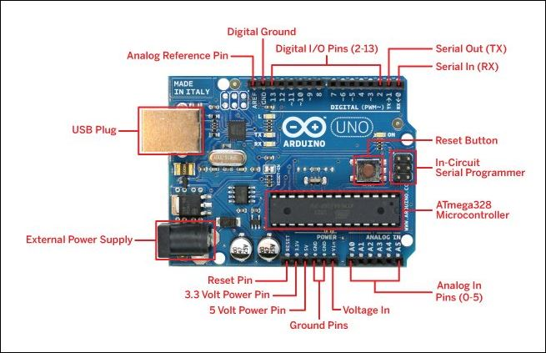Fig-7.2 : PIN DIAGRAM OF ARDUINO

**Communication**

The Arduino Uno has a number of facilities for communicating with a computer, another Arduino, or other microcontrollers. The ATmega328 provides UART TTL (5V) serial communication, which is available on digital pins 0 (RX) and 1 (TX). An ATmega16U2 on the board channels this serial communication over USB and appears as a virtual com port to software on the computer. The '16U2 firmware uses the standard USB COM drivers, and no external driver is needed. However, on Windows, a .inf file is required. The Arduino software includes a serial monitor which allows simple textual data to be sent to and from the Arduino board. The RX and TX LEDs on the board will flash when data is being transmitted via the USB-to-serial chip and USB connection to the computer (but not for serial communication on pins 0 and 1).

A SoftwareSerial library allows for serial communication on any of the Uno's digital pins.

The ATmega328 also supports I2C (TWI) and SPI communication. The Arduino software includes a Wire library to simplify use of the I2C bus; see the documentation for details. For SPI communication, use the SPI library.

**Programming**

The Arduino Uno can be programmed with the Arduino software (download). Select "Arduino Uno from the **Tools > Board** menu (according to the microcontroller on your board). For details, see the reference and tutorials.

The ATmega328 on the Arduino Uno comes preburned with a bootloader that allows you to upload new code to it without the use of an external hardware programmer. It communicates using the original STK500 protocol (reference, C header files). You can also bypass the bootloader and program the microcontroller through the ICSP (In-Circuit Serial Programming) header; see these instructions for details. The ATmega16U2 (or 8U2 in the rev1 and rev2 boards) firmware source code is available.

The ATmega16U2/8U2 is loaded with a DFU bootloader, which can be activated by:

• On Rev1 boards: connecting the solder jumper on the back of the board (near the map of Italy) and then resetting the 8U2.

• On Rev2 or later boards: there is a resistor that pulling the 8U2/16U2 HWB line to ground, making it easier to put into DFU mode.

**GPS MODULE**

GPS - GLOBAL POSITIONING SYSTEM

Used to detect the Latitude and Longitude of any location on the Earth, with exact UTC time (Universal Time Coordinated). GPS module is used to track the location of accident in our project. This device receives the coordinates from the satellite for each and every second, with time and date.

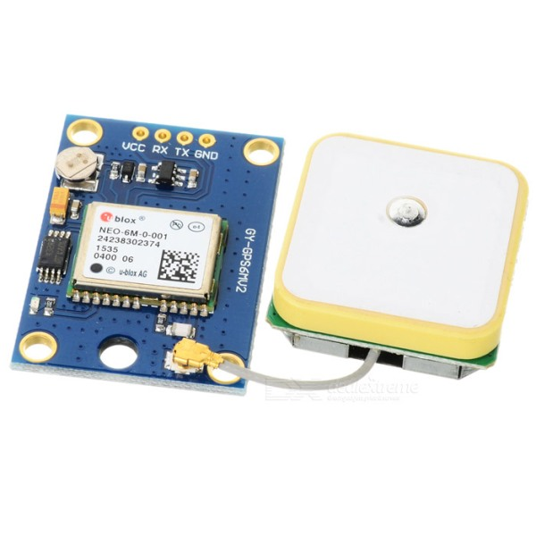  
 Fig-7.3 : GPS MODULE

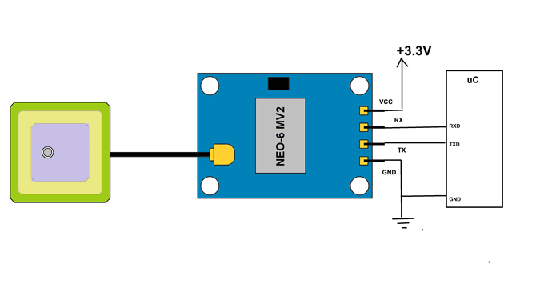

Fig-7.4 : PIN DIAGRAM OF GPS MODULE

**Overview of the NEO-6MV2 GPS Module :**This module is one of **popular GPS modules** in the market and is also cheap to buy. The location data provided by it is accurate enough to satisfy most applications. And for it to be included in smart phones and tablets design points out its efficiency. This module is famous among hobbyist and engineers altogether who want to work on applications involving navigation.

**GSM MODULE**

**GSM – GLOBAL SYSTEM FOR MOBILE COMMUNICATION**

GSM/GPRS module is employed to determine communication between a laptop and a GSM-GPRS system. International System for Mobile communication (GSM) may be a style used for transportable communication in the majority of the countries. it is a whole Quad-band GSM / GPRS module that can be merely embedded for a shopper or amateur use. SIM900 provides a daily sector interface. And delivers GSM / GPRS 850/900/1800 / 1900MHz voice usefulness, SMS , Low power data. It is easily available in the market.

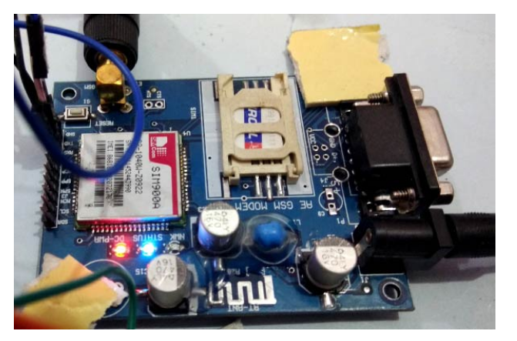

Fig-7.5 : GSM MODULE

# ****Functions Used****

1.  Sim900_test.readSMS(messageIndex, message, MESSAGE_LENGTH, phone, datetime)

* This function is used to read the message that is present at the location specified by **messageIndex**.
* **MESSAGE_LENGTH** is the size of the message that is to be read.
* **phone** is a character array in which the phone number of the sender of the message is extracted.
* **datetime** is a character array in which the date and time when the message was received is extracted.

2.  GPRS Sim900_test(PIN_TX,PIN_RX,BAUDRATE)

* This is used to create an object named Sim900_test (can have any other valid name according to user) of the class GPRS.
* It also defines the pins on Arduino board that are connected to the Rx and Tx pins of the Sim900A module. It also defines the baud rate used for communicating between the board an module.

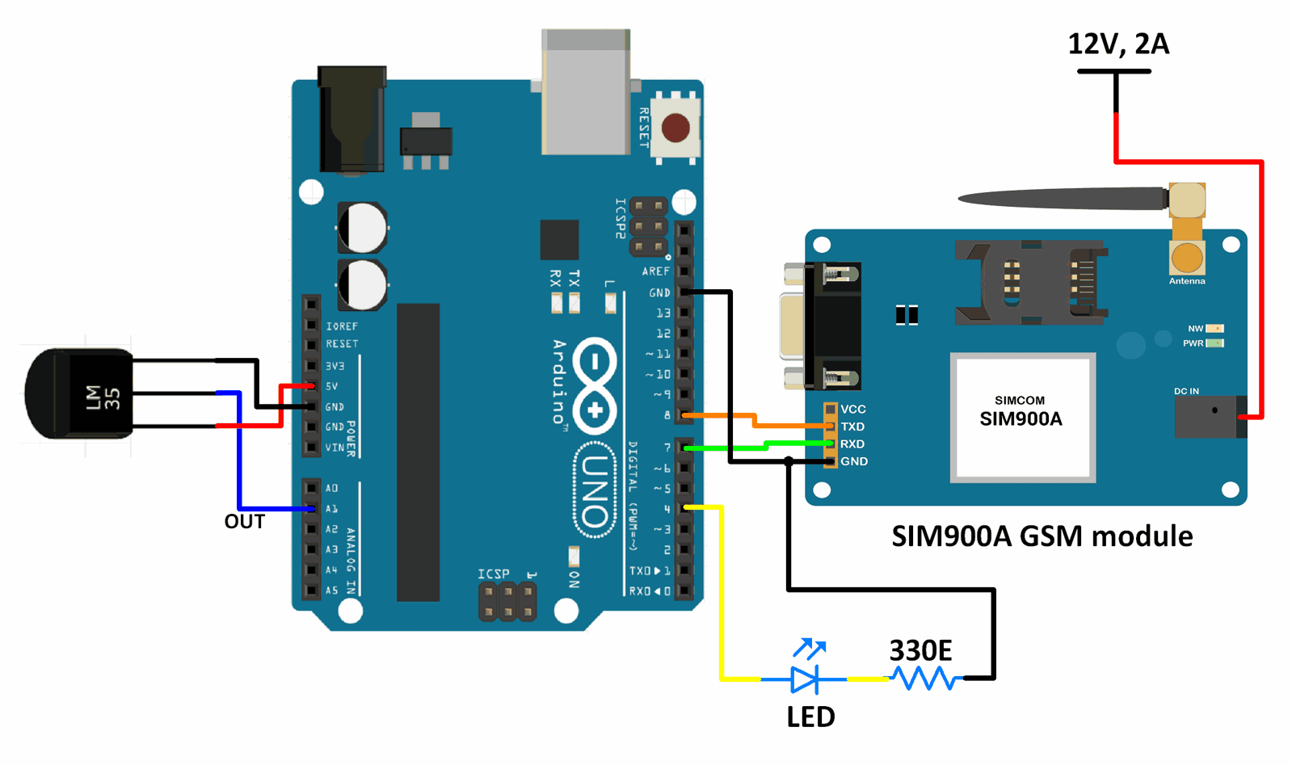

Fig-7.6 : **Interfacing Sim900A GSM Module With Arduino UNO**

**LCD MODULE**

To display the numbers, alphabets and special characters an LCD module with 16x2 alphanumeric types is used. Using the higher bit data lines of LCD pins such as pin 11,12,13 and 14 are interfaced to digital pins of Arduino such as pin 8,9,10 in 4 bit mode as shown in the below figure. RS and E pins of LCD are connected to pin 12 and 13. To perform the write operation on lcd to write and read the pin.

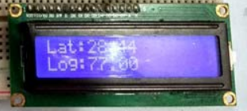

Fig-7.7 : LCD MODULE

## I2C LCD Basics

## This type of LCD is ideal for displaying text and numbers, hence the name ‘character LCD’.

The I2C LCD that we are using in this tutorial comes with a small add-on circuit mounted on the back of the module.

This module features a PCF8574 chip (for I2C communication) and a potentiometer to adjust the LED backlight.

The advantage of an I2C LCD is that the wiring is very simple. You only need two data pins to control the LCD.

Standard LCDs typically require around 12 connections, which can be a problem if you do not have many GPIO pins available.

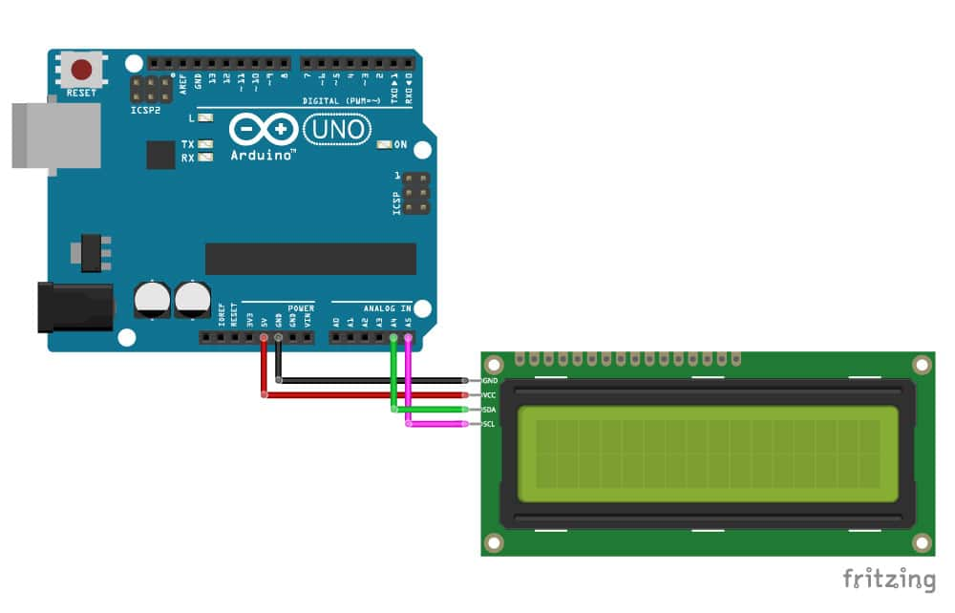

Fig-7.8 : LCD MODULE INTERFACE WITH ARDUINO

Here I use the same 16X2 LCD in my previous article. But additionally attach a I2C Module to the 16x2 LCD. It work as an inter mediator between the LCD and MCU (here Arduino).

Before starting you must know about **I2C Serial Interface Adapter** (I2C Module) , **I2C communication**, and **Addressof I2C LCD.**

I2C is short for Inter-IC. And it is a type of BUS. This is designed by Philips semiconductors. I2C is a synchronous, multi slave, multi master packet switched, single-ended serial bus. ie. multiple chips can be connect to the same bus.I2C uses only two bidirectional open collector or open drain lines, Serial Data Line (SDA) and Serial Clock Line (SCL), pulled up with resistors. Typical voltages used are +5 V or +3.3 V, although systems with other voltages are permitted. For more about I2C protocol.

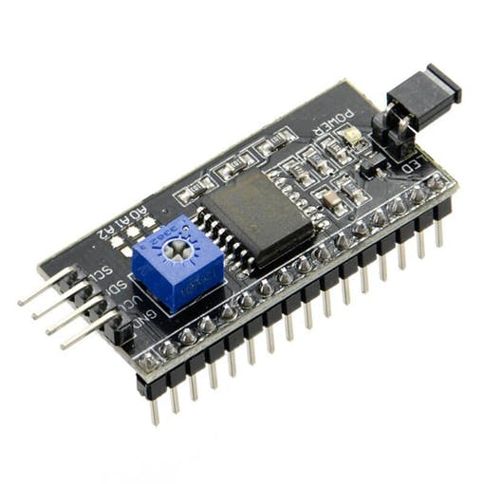

Fig-7.9: I2C Serial Interface Adapter

**ACCELEROMETER(ADXL335)**

Pin Description of accelerometer:

1. Vcc         5 volt supply should connect at this pin.
2. X-OUT   This pin gives an Analog output in x direction
3. Y-OUT   This pin give an Analog Output in y direction
4. Z-OUT   This pin gives an Analog Output in z direction
5. GND      Ground
6. ST          This pin used for set sensitivity of sensor

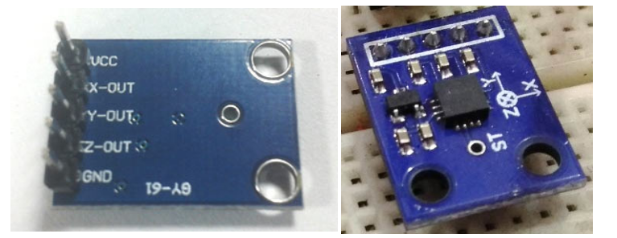

Fig-7.10 : ACCELEROMETER

# ADXL335 Accelerometer Interfacing with Arduino Uno

Accelerometer is an electromechanical device that measures the force of acceleration due to gravity in g unit.

It can be used in applications requiring tilt sensing.

The ADXL335 measures acceleration along X, Y and Z axes and gives analog voltage output proportional to the acceleration along these 3 axes.

Microcontrollers can process these voltages by converting them to digital signals using ADC.

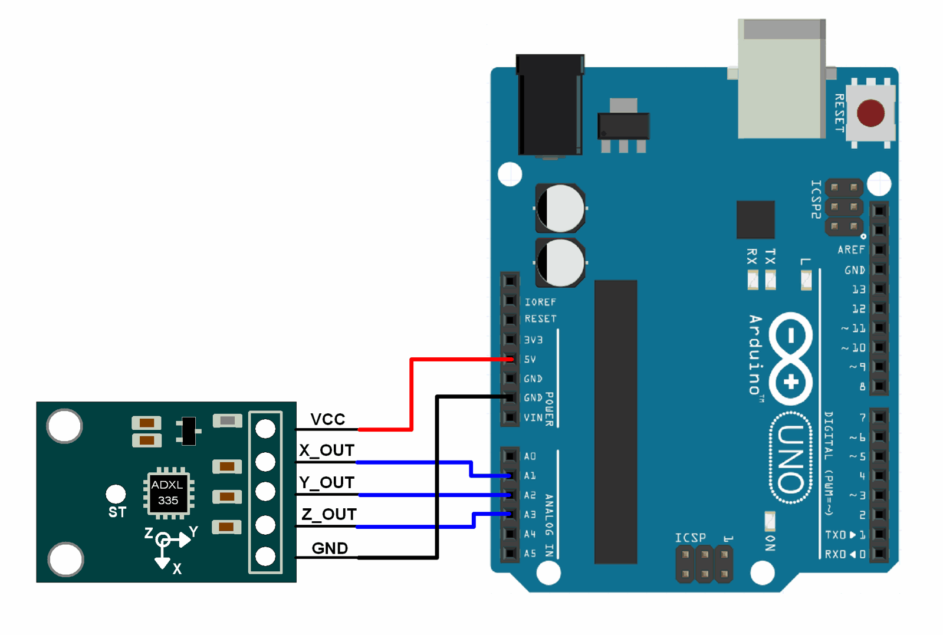

Fig-7.11 : **Interfacing ADXL335 Accelerometer Module With Arduino UNO**

**FEATURES**

3-axis sensing Small, low profile package 4 mm × 4 mm × 1.45 mm LFCSP Low power : 350 μA (typical) Single-supply operation: 1.8 V to 3.6 V 10,000 g shock survival Excellent temperature stability BW adjustment with a single capacitor per axis RoHS/WEEE lead-free compliant.

**APPLICATIONS**

Cost sensitive, low power, motion- and tilt-sensing applications Mobile devices Gaming systems Disk drive protection Image stabilization Sports and health devices.

**PERFORMANCE**

Rather than using additional temperature compensation circuitry, innovative design techniques ensure that high performance is built in to the ADXL335. As a result, there is no quantization error or nonmonotonic behavior, and temperature hysteresis is very low (typically less than 3 mg over the −25°C to +70°C temperature range).

**MQ3 SENSOR**

MQ3 is one of the most commonly used sensors in the MQ sensor series. It is a Metal Oxide Semiconductor (MOS) type of sensor. Metal oxide sensors are also known as **Chemiresistors**, because sensing is based on the change of resistance of the sensing material when exposed to alcohol. So by placing it in a simple voltage divider network, alcohol concentrations can be detected.

MQ3 alcohol sensor works on 5V DC and draws around 800mW. It can detect Alcohol concentrations anywhere from 25 to 500 ppm.

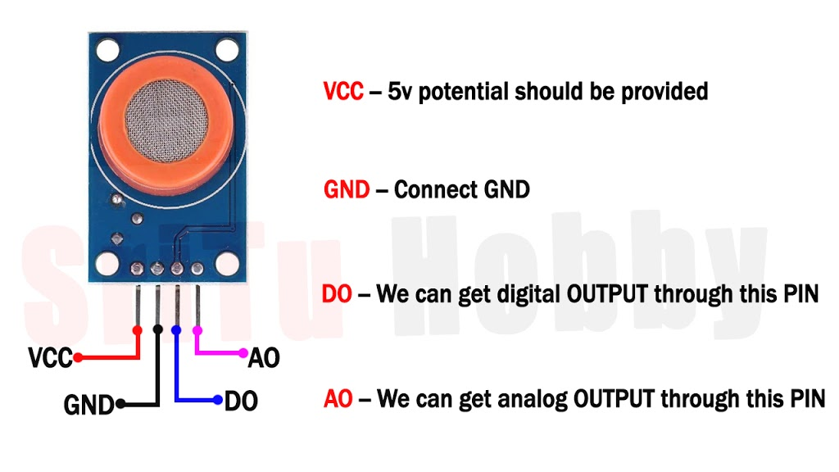

Fig-7.12 : MQ3 SENSOR

## How MQ3 Alcohol Sensor Works?

When SnO2 semiconductor layer is heated at high temperature, oxygen is adsorbed on the surface. In clean air, electrons from the conduction band in tin dioxide are attracted to oxygen molecules. This form an electron depletion layer just below the surface of SnO2 particles and forms a potential barrier. As a result, the SnO2 film becomes highly resistive and prevents electric current flow.

In the presence of alcohol, however, the surface density of adsorbed oxygen decreases as it reacts with the alcohols; which lowers the potential barrier. Electrons are then released into the tin dioxide, allowing current to flow freely through the sensor.

**CHAPTER – VIII**

**WORKING EXPLANATION**

**WORKING EXPLANATION :**

In this project, Arduino is employed to manage the whole method with GPS Receiver and GSM module. The GPS receiver is employed to seek out vehicle links, the GSM module is employed to send SMS alerts with location and a link to Google Map. The ADXL335 measuring system is employed to sight associate degree accidents or unforeseen amendments in any axis. We tend area unit mistreatment GPS Module SIM28ML and GSM Module SIM900A.

Once we tend to area unit prepared with our hardware once the program, we will install it in our automobile and power it up. Currently whenever there's an associate accident, the automobile slides down and therefore the measuring instrument changes its axis values. These numbers area unit browse by Arduino and assess whether or not there's an amendment in any axis. Within the event of associate amendment Arduino reads the coordinates by extracting the $ GPGGA string from the GPS module knowledge and causing an SMS to the predefined range to the police or automobile or loved one via the placement of the accident website. The message conjointly contains a Google Map link to the place of the accident, so the placement is simply half-track.

**CHAPTER - IX**

**CIRCUIT CONNECTIONS**

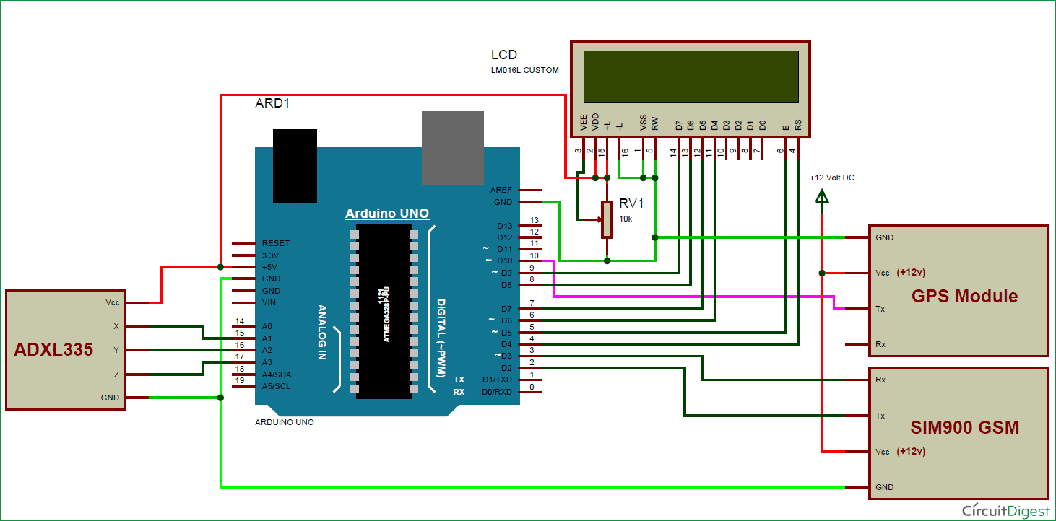

Fig-9.1:CIRCUIT CONNECTION OF ACCIDENT DETECTION SYSTEM

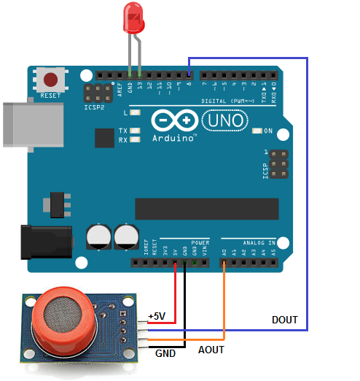

Fig-9.2 : MQ3 SENSOR INTERFACE WITH ARDUINO

**CHAPTER – X**

**RESULTS AND DISCUSSION**

**RESULTS AND DISCUSSIONS :**

After all the elements are connected properly, the framework is placed into a moving automotive. If an associate degree accident happens, the accident thanks to the acceleration that occurred is detected by the ADXL335 measuring instrument.  
The x, y and coordinate axis ADC output pins of the measuring instrument are directly associated with Arduino ADC pin A1, A2, and A3.

After effective transcription and uploading the program to Arduino IDE, the system is instated with success, the measuring device is aligned and also the x , y and z samples of the vehicle area unit are shown on the serial monitor.



Fig-10.1 : The successful initialization of the system is displayed in the LCD

After receiving the GPS signal, the latitude and longitude of the current position of the vehicle are displayed, The speed is displayed in knots.



Fig-10.2 : After receiving the GPS signal, the latitude and longitude of the current position of the vehicle is displayed.

When the measuring system is agitated abnormally, i.e., within the event of AN accident once there's a sudden distinction in a pivot, SMS is shipped to the mobile range documented within the code and therefore the latitude and line of longitude is additionally sent as Google maps. The message is received within the preset mobile range beside the particular space.



Fig-10.3 : Message received by the specified phone number



Fig-10.4 : Location of the accident sent via Google Map.

**CHAPTER - XI**

**CONCLUSION**

**CONCLUSION**:

As per the study, it tends to be seen that a range of works is done until currently during this field. Several performed the tasks to sight the accident, establish the accident spot, give alert messages to the driving force, and then forth. During this project, the system “Vehicle trailing System and Accident Detection” is intended by exploitation GSM and GPS. For the purpose once associate degree accident happens, the co-ordinates of the situation of accident obtained by the GPS, square measure sent via the GSM network to the registered mobile numbers. This paper provides the work to sight associate degree accident also on forestall that. The execution of the system to the vehicle would prompt to enhanced vehicle price on one hand, nevertheless would likewise build the chances of being protected on-road and keeping one from any accident. The projected framework is discovered to be deeply helpful relating to deciding the accident location to produce the short rescue to the injured individual.

**CHAPTER - XII**

**FUTURE SCOPE**

**FUTURE SCOPE :**

Vehicle accidents are hugely increasing day by day. Therefore, it becomes very necessary to work out a way to decrease it. From this paper, it tends to be seen that such a framework will save numerous lives. As of now, the framework is utilizing the realm-supported GPS and using an alarm message by the GSM module. This framework is often extended in a while by incorporating it with Google Maps. Another upgrade is often within the message-causing module. Other than causing the message to the listed numbers solely, an alarm message would what is more be sent to the obtainable accessible emergency vehicle or the medical clinics.

**CHAPTER-XIII**

**REFERENCES**

**REFERENCES:**

**1** . **GOWSHIKA. B, MADHU MITHA. G, JAYASHREE. S, S. MUTHARASU**

Student, Dept of Electrical and Electronics Engineering, Vivekanandha college of Engineering for Women[Autonomous], Namakkal, India Assistant Professor, Dept of Electrical and Electronics Engineering, Vivekanandha college of Engineering for Women[Autonomous], Namakkal, India.

**2** . **J. Mounika, N. Charanjit, B. Saitharun & B. Vashista**

Assistant Professor, Dept. of ECE, Chaitanya Bharathi Institute of Technology, Osmania University, Hyderabad, Telangana, India. BE Scholar, Dept. of ECE, Chaitanya Bharathi Institute of Technology, Osmania University, Hyderabad, Telangana, India.

3 . **G. Boopathi Raja, Keerthika A, Keerthika S G, Nandhini A,Pranitha K J**

Assistant Professor, Final year ECE students Department of ECE, Velalar College of Engineering and Technology, Erode – 638012.

4 . **Zainab Mohammed Khamis Al-Balushia, Safaa Saeed Khalfan Al-Taaleia, A.Jamaludeena**

5 . **Dr. Pradnya Mathurkar, Akansha B. Somkuwar, Ashwini R. Thakre, Pranali M. Wasnik**

Faculty, Department of Electronics and Telecommunication Engineering Students, Department of Electronics and Telecommunication Engineering Rajiv Gandhi College of Engineering and Research, Nagpur, Maharashtra, India

6 . **Aswin M, Sujitha E, Archunan P ,Sandhya Devi R S**

Department of Electrical and Electronics Engineering, Kumaraguru College of Technology [autonomous], Coimbatore, India Assistant Professor, Department of Electrical and Electronics Engineering, Kumaraguru College of Technology [autonomous], Coimbatore, India.

**7 . B. Rani , R. Praveen Sam , Govardhan Reddy Kamatam**

A PG Scholar, Dept. of Computer Science & Engineering, G. Pulla Reddy Engineering College, Kurnool, India Professor, Dept. of Computer Science & Engineering, G. Pulla Reddy Engineering College, Kurnool, India Associate Professor, Dept. of Computer Science & Engineering, G. Pulla Reddy Engineering College, Kurnool, India